**Exercise 1: Control Structures**

Scenario 1: The bank wants to apply a discount to loan interest rates for customers above 60 years old.

Inserted two necessary columns in Customers and Loans table to check the output,

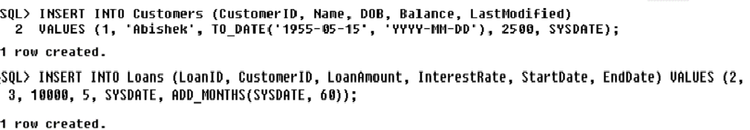

**PL/SQL Code:**

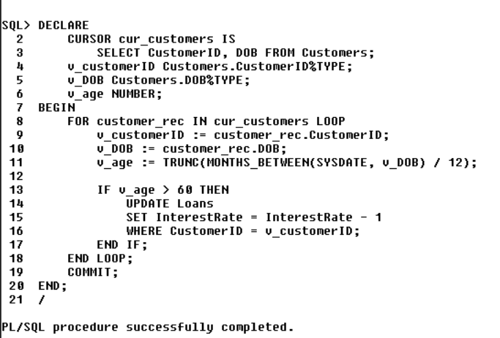

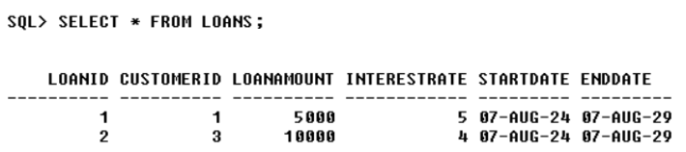

Scenario 2: A customer can be promoted to VIP status based on their balance.

Added “IsVIP” column to the Customers table.

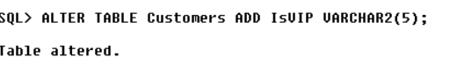

**PL/SQL Code:**

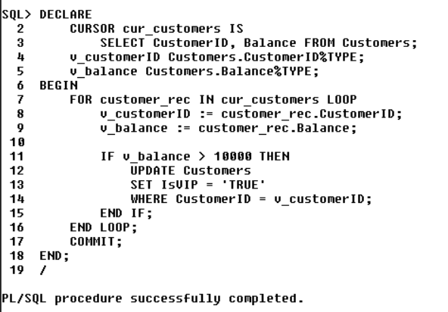

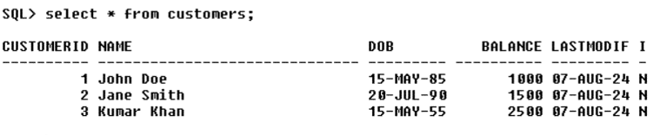

Scenario 3: The bank wants to send reminders to customers whose loans are due within the next 30 days.

**PL/SQL Code:**

